Nutritious Birthday Party Order Form
Metz Culinary & Abington Heights offer healthy and allergy friendly celebration packages to purchase for any school celebration every day of the school year!
Orders must be submitted one week in advance!
$1.45 per person
Includes a beverage choice, snack choice, small prize per child, and paper supplies.

Child’s Name: _________________________________________________________________
Ordered by: __________________________________________________________________
Phone #: _____________________________________________________________________
Email: _______________________________________________________________________
Delivery Date: ________________________________________________________________
School: ______________________________________________________________________
Teacher: _____________________________________________________________________
Grade: ______________________________________________________________________
# of Children in class: ____________________________________________________
Food Item Requested: ____________________________________________________
Second Food Item Option: _________________________________________________
Drink Item Requested: ______________________________________________
Make Payment to AHSD Hot Lunch Fund
PAYMENTS MUST BE EXACT AMOUNT
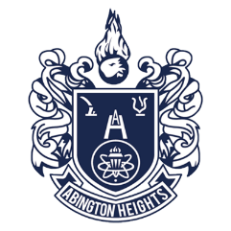
Excess is not able to be deposited into student’s account
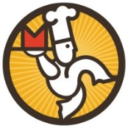
MUST ORDER ATLEAST ONE WEEK IN ADVANCE
Nutritious Party Menu
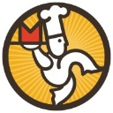

Snack Choices
Goldfish Grahams
Pretzel Hearts

Drink Choices
Water
100% Fruit Juice (Apple)

